Thyroid orbitopathy:

Distance of the anterior surface of orbit from intezygomatic line is [] (normal is < 23 mm).

[Retroorbital muscles show increased T2 signal] and appear bulky mainly in the region of belly (relative sparing of the distal tendinous region).

The thickness of Inferior rectus muscle is =

The thickness of the medial rectus muscle is= **most important for prognosis

The thickness of the superior rectus muscle is =

[Retroorbital fat appears bulky ]

[Superior ophthalmic vein is patent] [and is not compressed] [but compressed]

Lacrimal gland is [normal]

Barret’s index is []. Optic nerve shows normal signal and appearance.

\*\*\***Barrett's index** is used to assess for dysthyroid [optic neuropathy](https://radiopaedia.org/articles/optic-neuropathy?lang=gb), a severe complication of [thyroid-associated orbitopathy](https://radiopaedia.org/articles/thyroid-associated-orbitopathy-1?lang=gb) that can lead to permanent blindness 1.

**Measurement**

**Helps predicting dysthroid optic neurpathy**

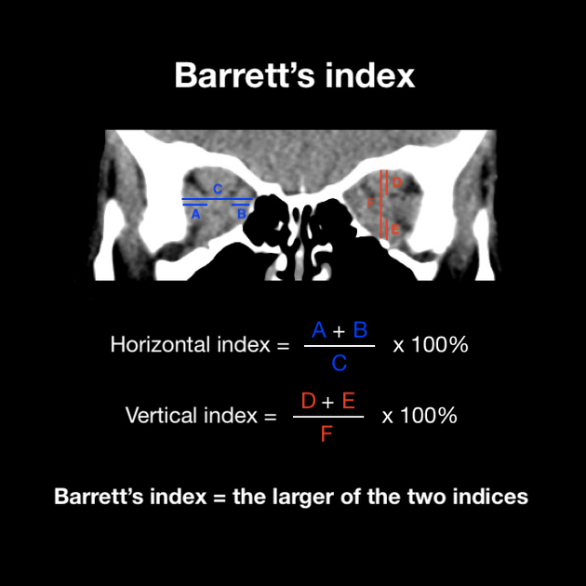

Measurement is calculated on coronal CT or MRI imaging of the orbits at a point halfway between the posterior globe and the orbital apex. Two measurements are taken for each eye:

* horizontal index
  + (width of [medial rectus](https://radiopaedia.org/articles/medial-rectus-muscle?lang=gb) + width of [lateral rectus](https://radiopaedia.org/articles/lateral-rectus-muscle?lang=gb)) / orbital width through [optic nerve](https://radiopaedia.org/articles/optic-nerve?lang=gb) x 100%
* vertical index
  + (height of [superior rectus](https://radiopaedia.org/articles/superior-rectus-muscle?lang=gb) + height of [inferior rectus](https://radiopaedia.org/articles/inferior-rectus-muscle?lang=gb)) / orbital height through [optic nerve](https://radiopaedia.org/articles/optic-nerve?lang=gb) x 100%

The larger of these two indices represents the more significant impingement and is the value taken as Barrett's index 2.

**Interpretation**

A Barrett's index of ≥60% is highly sensitive and specific for dysthyroid [optic neuropathy](https://radiopaedia.org/articles/optic-neuropathy?lang=gb) 3. A Barrett's index of <50% almost always excludes dysthyroid [optic neuropathy](https://radiopaedia.org/articles/optic-neuropathy?lang=gb) 1.

**History and etymology**

This method was first described by American radiologist **Lynn Barrett** in 1988 2.

[Normal] appearance of bony wall of orbit.